to bring together or into contact
Connect

How do you talk to your child about your separation?

How do you communicate with your ex-partner?

How do you manage your own emotions?

This information can help you to get things right for your children when you separate

For further information contact Helen Evans
helenevans.connect@gmail.com
07743 001622

Extended parental conflict results in negative outcomes for children at school, with their friends and with their lifelong partners.

Separation and co-parenting

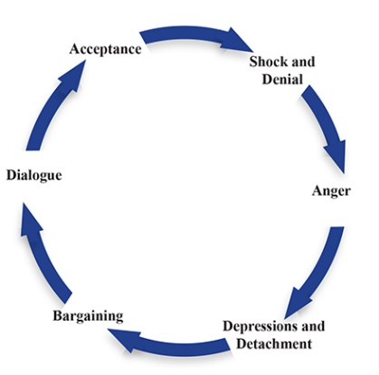
When you separate you will go through the loss cycle which is similar to a bereavement. Your emotions can be all over the place, it can feel like you are spinning through worry, anger, shock, depression, bargaining, helplessness. Everyone will need time to adjust to a ‘new normal’. It can help you to recognise that these feelings are normal and that we all feel them, just at different times.

You need to put your child’s needs first even when it hurts you. You need to listen to how they feel and not expect them to feel the same way that you do because they love both of their parents. They want to be able to have fun and do normal everyday things with both of you.
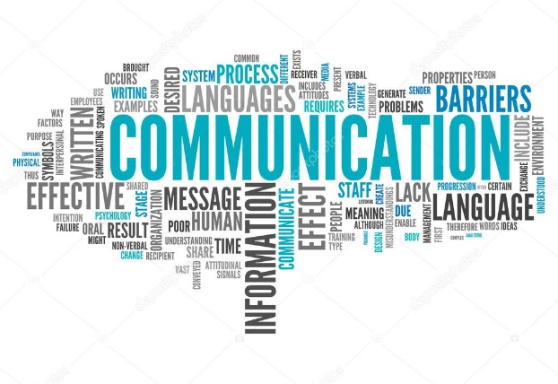
Can you adjust your relationship from an emotional one to a business like one so that you can co-parent your child? You are no longer partners, but you will always be Mum and Dad. You will parent differently to your ex-partner but that does not make the things they do wrong, just different. Try not to criticise them in front of your child, they really do not like it as they look at themselves as half Mum/half Dad.

Lack of communication is the main issue for separating parents, first you need to talk to your child. You need to tell your child what will change for them. That they will have two homes where they belong. Will they have to move to a new house? Will their school stay the same or not? How will they keep in touch with extended family such as cousins, aunts, uncles, grandparents who are very important people in their lives? Where will the dog live? Tell them what you think will stay the same and what things might change. Tell them it is ok to feel sad and worried about change, but that you will help them through it.

What children say …
I need to be close to both of you, to do normal things together
I don’t know why they left and don’t want to see me, was it my fault? If I had not been naughty, they would not have argued

It makes me feel bad when you say horrible things about them. It doesn’t matter if we don’t live together as long as you both love me

I’m not allowed to talk about them, and it makes me sad because I still love them
I want to know what is happening but not whose fault it is or the reasons why

What children want to know …

- That it is OK to love both of you
- It is not their fault
- Things may be different but that’s ok, you can cope with different rules in each home
- They have two homes where they belong
- It is good to like a stepparent and their children, that’s lots more people to love us
- They don’t need to look after a parent or be like a gown-up friend
- Who else can I talk to so that I don’t upset you?
- How things will work out
- Will you be OK when I am not here with you?

What children feel …

Scared upset lonely frightened hurt rejected confused Safe calm relieved hopeful

You need to help your child to understand these emotions by talking about them without being critical of anyone, explain that these feeling are normal and will not last forever. Don’t let your child emotionally support you.

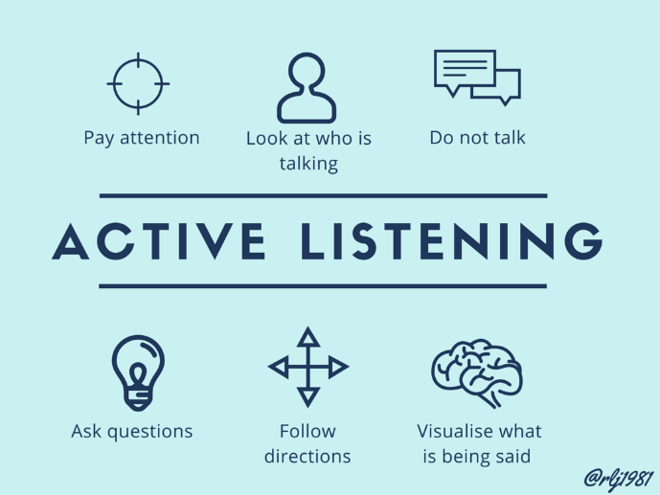
Effective communication
When you start to listen, you might be surprised by what you hear, don’t assume you know what they are going to say
To LISTEN you need to be SILENT
Take time to consider your answer, don’t rush yourself into something you can’t do
Be clear and stick to the point, don’t bring up other issues

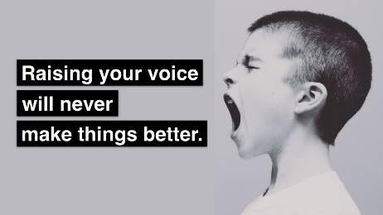
If it gets heated, don’t escalate things, stop the conversation
Don’t jump in to fill a gap, give them time to think
Don’t blame. Suggest a solution, make an offer, your child matters more than your feelings do

Don’t … | Do this instead …
Question your child about their other parent | Give them time and the opportunity to tell you things if they want to
Be a competitive parent | Give your child your time and attention, not the biggest gift
Stop your child from seeing a parent and extended family | Let them enjoy their relationships without feeling guilty
Compare the two homes | Encourage your child to feel comfortable in both homes
Focus on all the negatives | Remember your child loves that parent, just like you used to
Put up barriers | Be prepared to negotiate in the best interests of your child
Argue in front of your child | Have discussions when your child is not present and able to hear you
Try to control the other parent | Focus on what you need to do and how well you do it
Tell your child adult information | Use an age appropriate filter, don’t damage them by giving them information they cannot understand or process
Emotionally exhaust yourself | Look after yourself, eat well, get some rest, do things just for you, these things will help you to move on
Expect your child to choose sides | Recognise that they are half mum/half dad, they don’t want to know who was right and wrong
Use your child to pass messages because you don’t want to communicate | Find other ways to communicate if you can’t do that directly yet. Use a third party, or an online app
Get stuck at one of the stages of loss | Show your child how to move on after disappointment and upset
Try to sort everything out straight away | Take small steps, sort out one small thing at a time, give everyone time to adjust to change
Focus on what your ex-partner should or shouldn’t do | You can only control your own behaviour and what you say or how you react, remember you are your child’s role model
Listen to everyone else’s experiences of separation | Your separation is unique to you – get some neutral, impartial information to help you to decide on a way forward

For further information contact Connect:
www.connectnorthyorkshire.co.uk
helenevans.connect@gmail.com
07743 001622

